**建平实验小学一年级学习准备期英语小乐园**

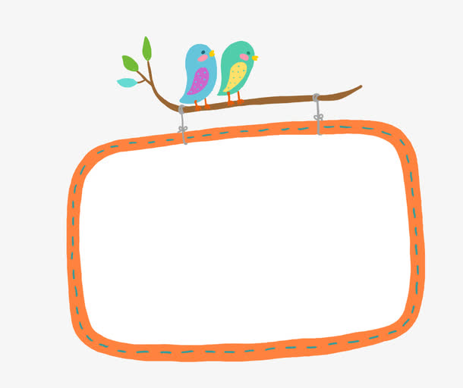**Class__________ Name_________ No._______**

亲爱的一年级小朋友们，经过四周准备期的学习，我们在Look and say（看看说说）中学习了和老师打招呼；在Play and chant（玩玩演演）中认识了我们的学习用品；在Say and act（说说做做）中学会了介绍教室和学校；在Sing and dance中表演了许多好听的英语歌曲。现在请你和家长一起对自己这四周的课堂表现、课后复习情况做出评价。希望所有的小朋友们，在今后的英语学习中敢于表达、善于交流，成为英语学习中的小博士！

**Part 1: Self-appraisal(我的自评)**

1. **My feeling(学习兴趣)**

|  |  |  |  |  |  |
| --- | --- | --- | --- | --- | --- |
| My feeling  我喜欢 ... | HAPPY%~1  Phonics  语音 | HAPPY%~1  Word 词汇 | HAPPY%~1  Dialogue对话 | HAPPY%~1Rhyme 儿歌 | HAPPY%~1  Song 歌曲 |
| √ |  |  |  |  |  |

**2.My attitude(学习习惯)**

|  |  |  |
| --- | --- | --- |
| Listening Habbits | 1. Listen to the teacher   认真听讲   1. Listen to my classmates   认真倾听同学发言 |  |
| Talking Habbits | 1. Try answer questions   积极举手发言   1. Try to talk in English   喜欢用英语交流 |  |

**Part 2: Parents' Assessment(家长评价)**

|  |  |  |
| --- | --- | --- |
| Listening Habbits | 1. Listen to the tape   认真听音频或看视频 |  |
| Reading Habbits | 1. Try to follow  认真跟读、跟唱 |  |

**Part 3: Teacher's Assessment(教师评价)**

|  |  |  |  |  |
| --- | --- | --- | --- | --- |
| Listening Habbits | 1. Listen to the teacher  认真听讲  2. Listen to others  认真倾听同学发言 | Excellent  太棒了！ | Good  好！ | OK！  加油！ |
|  |  |  |
| Talking Habbits | 1. Try answer questions  积极举手发言  2. Try to talk in English  喜欢用英语交流 | Excellent  太棒了！ | Good  好！ | OK  加油！ |
|  |  |  |
| Homework | 1. Make a new rhyme   自编新的儿歌   1. Read the dialogue   朗读对话 | Excellent  太棒了！ | Good  好！ | OK  加油！ |
|  |  |  |

